# VARDHAMAN COLLEGE OF ENGINEERING, HYDERABAD

**Autonomous institute affiliated to JNTUH**

##### DEPARTMENT OF MECHANICAL ENGINEERING

##### Academic Year: 2024 –2025

##### B. Tech IV Year I Semester – ME

##### **PRODUCTION PLANNING AND CONTROL**

**UNIT-III**

**Introduction**

**Inventory :** “The term inventory include materials- raw, in progress, finished packaging, spares, and other stock in order to meet an un expected demand or distribution in the future.”

**Inventory Control:** “inventory control is a scientific system which indicates as to what to order, when to order, and how much to order, and how much to stock so that purchasing costs and storing costs are kept as low as possible.

**Classification**

Broadly Classified into

Direct inventory Indirect inventory

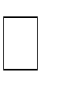

1. **Direct inventory**

which play a direct role in the manufacture of a product and becomes an integral part of the finished product are called direct inventories.

Raw materials



Inprocess inventories (= work in progress)

Purchased parts (purchasing of some components instead ofmanf. in theplant) Inished goods.

1. **Indirect inventory**

Indirect inventories are those materials which help the raw materials to get converted into the finished products, but do not become an integral part of the finished products.

It helps the raw materials to get converted into finished part. such as: Tools

Supplies

* miscellaneous consumable – brooms, cotton, wool, jute, etc.
* welding electrode, soldersetc.
* abrasive mat – emery cloth, sand paper etc.
* brushes, maps, etc.
* oil greases etc.
* general office supplies – candles, sealing wax etc.
* printed forms such as – envelope, letter heads, quotation forms etc.

### Benefits of Inventory Control

* Ensures an adequate supply of materials
* Minimizes inventory costs
* Facilitates purchasing economies
* Eliminates duplication in ordering
* Better utilization of available stocks
* Provides a check against the loss of materials
* Facilitates cost accounting activities
* Locates & disposes inactive & obsolete store items
* Consistent & reliable basis for financial statements

**Relevant inventory costs**

* 1. Ordering Costs
  2. Carrying Costs
     + Capital Costs
     + Storage Space Costs
     + Inventory Service Costs
     + Handling-equipment Costs
     + Inventory Risk Costs
  3. Out-of-stock Costs or Shortage Cost

1. 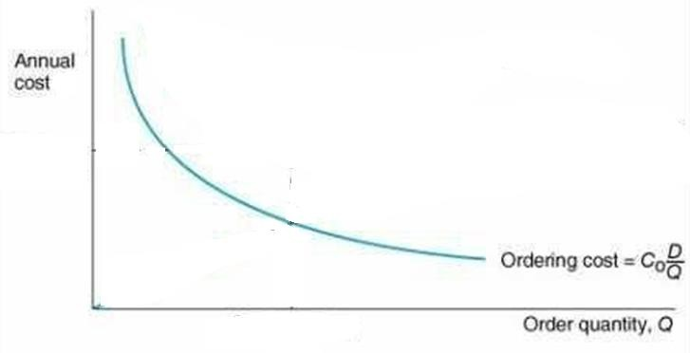**Ordering cost:** — Costs of ordering and receiving inventory
   * Determining how much is needed,
   * Tendering,
   * Follow-up the purchase order,

* Preparing the purchase order & invoices,
* Inspecting goods upon arrival for quality and quantity,
* Moving the goods to temporary storage.

1. **Holding (Carrying) costs —** Cost to carry an item in inventory for a length of time

### Cost of capital

Since inventory is equivalent to locked-up working capital the cost of capital is an important relevant cost. this is the opportunity cost of investing in inventory.

### Space cost

Inventory keeping needs space and therefore, how much and when question of inventory keeping are related to space requirements. this cost may be the rent paid for the space.

### Materials handlingcost

The material need to be moved within the warehose and the factoryand the cost associated with the internal movement of materials (or inventory) is called materials handling cost.

### Obsolescence, spoilage or Deterioration cost

If the inventory is procured in a large quantity, there is always a risk of the item becoming absolute due to a change in product design or the itemgettingspoiledbecauseofnaturalageing process.Suchcosthasa relation to basic question of how much and when?

### Insurance costs

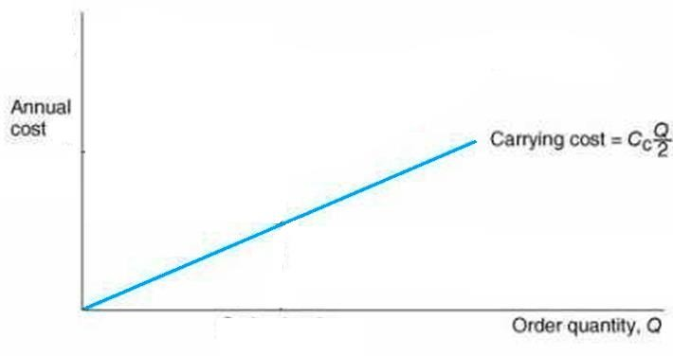There is always a risk of fire or theft of materials. a firm might have taken insurance against such mishaps and the

insurance premium paid are the relevant cost.

### Cost of general administration

Inventory keeping will involve the use of various staffs. with large inventories, the cost of general administration might go up.

### Shortage costs or Stock-out Costs

The cost associated to failing to supply customers' order for a misjudge the order-quantity and inventory runs out.

* + Costs resulting when demand exceeds the supply of inventory

### Economic order quantity :

It is the ordering quantity which minimises total carring and ordering costs for the year

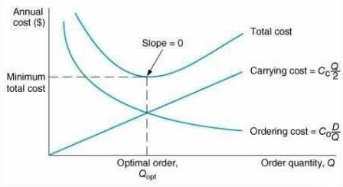

The result is the most cost effective quantity to order. In purchasing this is known as order quantity, in manufacturing it is known as the production lot size.“

Definition of EOQ " EOQ is essentially an accounting formula that determines at which the combination of order, costs and inventory carrying cost are the least.

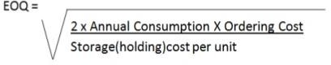

### Assumptions of EOQ:

* Demand for the product is constant
* Lead time is constant
* Price per unit is constant
* Inventory carrying cost is based on average inventory
* Ordering costs are constant per order
* All demands for the product will be satisfied (no back orders)

**Derivation for Economic order quantity (EOQ):**

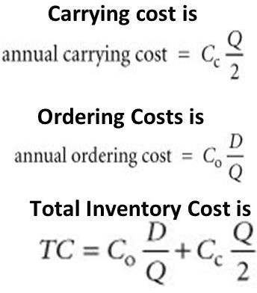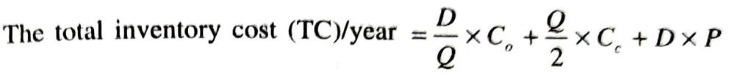

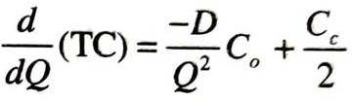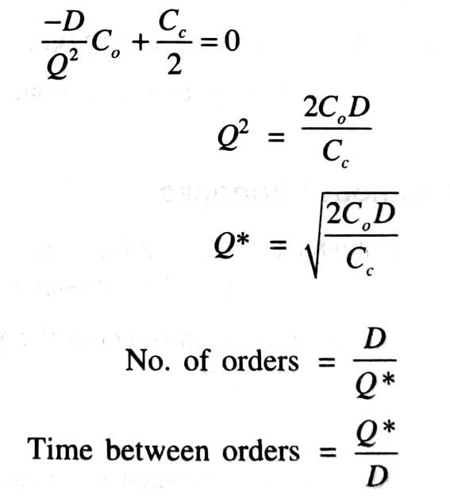

## DETERMINISTIC MODELS

Method based on the assumption that all parameters and variable associated with an inventory are known or can be computed with certainty, and that the replenishment lead time is constant and independent of the demand.

The various deterministic models taken into account are:

1. Purchase model with instantaneous replenishment and without shortages
2. Purchasing model with instantaneous replenishment and with shortages
3. Manufacturing model without shortages
4. Manufacturing model with shortages

### Purchase model with instantaneous replenishment and without shortages

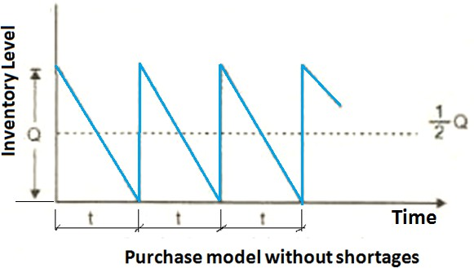

In this case, the orders of equal sizes are placed at periodical intervals. The items against an order are replenished instantaneously and the items are consumed at constant rate. The purchase price per unit is same irrespective of the order size.

D= Annual demand of an item

Co = Ordering cost per order

Cc = Carrying cost per unit per period. P = Cost of production per unit

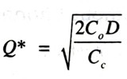EOQ = Economic ordering Quantity t = Total cycle time

Economic ordering Quantity(EOQ)

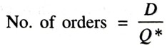

Total cycle time = **Q / D**

### Purchasing model with instantaneous replenishment and with shortages

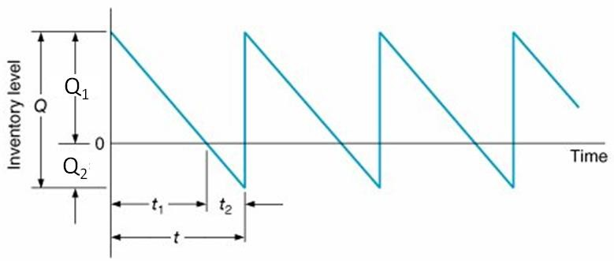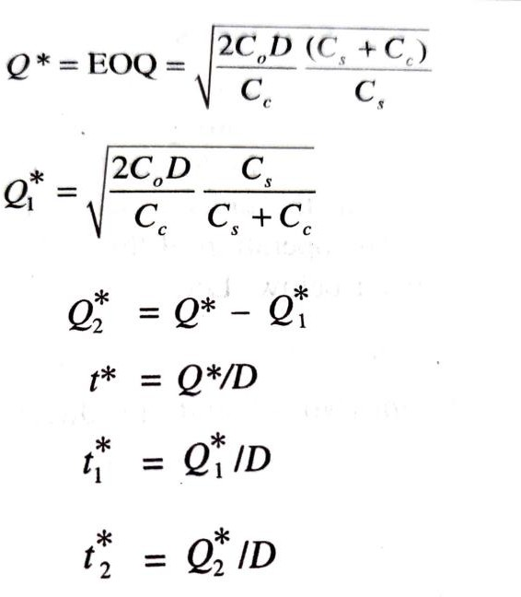

D= Annual demand of an item

Co = Ordering cost per order

Cc = Carrying cost per unit per period.

P = Purchase cost per unit t1= Inventory period

t2= Inventory period t = Total cycle time

EOQ (Q)= Economic ordering Quantity Q1= Maximum inventory quantity

Q2= Maximum shortage quantity

### Manufacturing model without shortages

If a company manufacture its component which is required for its main product, then the corresponding model of inventory is called ® manufacturing model.

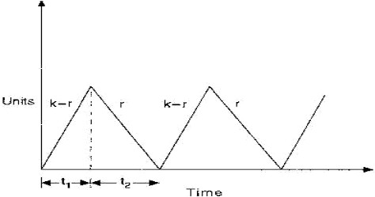This model will be without/with shortage. The rate of consumption of item is uniform throughout the year. The cost of production per unit is same irrespective of production lot size.

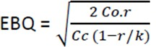r= Annual demand of an item k = Production rate of item

(No. of units produced per year) Co = Cost per set-up.

Cc = Carrying cost per unit per period.

P = Cost of production per unit EOQ = Economic Batch Quantity t = Total cycle time



t1 = Period of production as well as consumption t2 = Period of consumption only

### Manufacturing model with shortages

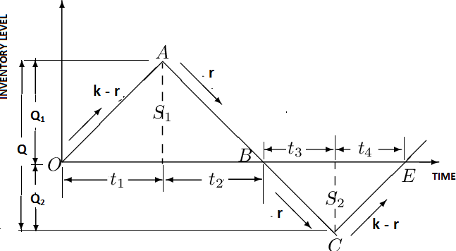

r = Annual demand in units

k = Production rate of the item Co = Cost per set up

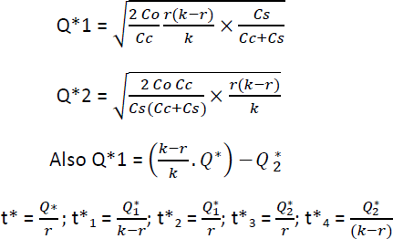Cc= Carrying cost per unit per year Cs=Shortage cost

Q=Order size Q1=Maximum inventory Q2=Maximum stock out

P= Cost of production per unit t = total cycle time

t1 = Period of production as well as consumption t2 = Period of consumption only

t3= Period of shortage

t4= Period of production as well as consumption of the item satisfying back order

### Fixed Order Quantity System (Q System):



* Very elementary and most commonly used system.
* It is also called the min-max system.
* The items are divided into two bins: the first one is for satisfying the current demand, while the second one is to satisfy the demand during the replenishment period.

Items are withdrawn from bin-1 until its contents are exhausted; then place an order using order card placed at bottom of first bin.

Bin-2 contains enough stock to satisfy expected demand until the order is filled, plus extra cushion of stock that reduces the chance of stock-out if the order is late or if usage is greater than expected.

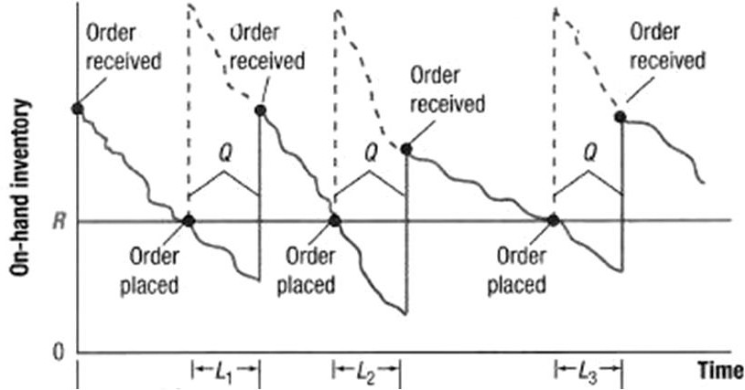

In this system of inventory whenever the stock level touches the reorder level, an order is placed for a fixed quantity which is equal to EOQ.

* + The average demand during the lead time (average lead time) is known as the demand during lead lime (DLT).
  + The variation in demand during lead time (average lead time) is known as safety stock.
  + The average demand during delivery delays is called reserve stock.

### Reorder Level = Demand during lead time + Safety stock + Reserve stock Merits of 'Q' system

* + - It Is simple, reliable, and easy to explain and operate,
    - There Is no need to record each withdrawal from Inventory.
    - Each material can be in the most economical quantity;
    - Purchasing an inventory control personnel automatically devote attention to the items that are needed only when required; and
    - Positive control can be easily exerted to maintain total inventory investment at the desired level, simply by manipulating the plant maximum and minimum values.

### Demerits of 'Q' system

* + Reorder card may not be turned In for a variety of reasons (e.g., misplaced, the person responsible forgets to turn It In),
  + Absence of adequate data on stock levels and consumption rates.
  + Affects the evaluation of batch sizes for orders that can be reduced by slow, medium, and fast moving.
  + The orders are raised at irregular intervals which may not be convenient to the suppliers
  + In case the lead time is very high supply of inventory may interpret
  + EOQ may give you an order quantity which is much below the supplier minimum, and there is always a chance that the ordering level for an item has been reached but not noticed in which case a stock out may occur;
  + The items cannot be group and ordered at a time since the recorder points occur irregularly.

### Periodic Review System (P System):

Periodic Review System (P System) Is this system of inventory, the stock position is reviewed once in a fixed period and an order is Placed depending on the stock position, unlike a fixed quantity in the Q System of inventory.

The review period is approximately equal to EOQ/D.

### Maximum Inventory Level = Demand during lead time & review period + Safety stock

**+ Reserve stock**

The Desired Maximum Inventory Level is fixed, the sum of average demand during average lead time plus review period, variation in demand during average lead time plus review period, and the average demand during delays in supply.

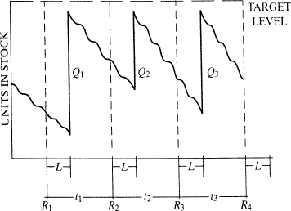

### Merits of P model

* + All orders for replenishment are issued at the same time.
  + Ordering mechanism is regular and not subject to periodic arrivals of warning signals from the store.
  + The ordering and inventory cost are low;
  + The supplier will also offer attractive discount on sales are granted
  + The system works well for material which exhibit an irregular or seasonal use and whose purchase must be planned in advance on the basis of sales estimates.

### Demerits of 'P' model

* + It compels a periodic review of all item this in itself make the system somewhat inefficient. because of difference in uses rate supply may not have to be order until succeeding review
  + Equally important the system demand the establishment of rather inflexibility order quantities. in The interest of the administrative efficiency;
  + The periodic review system tends to peak the purchasing work around the review dates.

### Inventory control methods

* ABC Analysis (Always Better Control)
* VED Analysis (Vital {absolutely necessary/very important } , Essential, Desirable)
* HML Analysis (High, Medium, Low)
* FSN Analysis (Fast, Slow moving and Non-moving)
* SDE Analysis (Scarce { t(x) small to meet the needs }, Difficult, Easy)

**ABC analysis** (ABC = Always Better Control)

One of the most important considerations of control is the value of annual consumption of inventory items in a year.

* Only a small number of inventory items consume a very large share of inventory consumption during the year.
* A little larger number of inventory items covers a moderate share of annual inventory consumption.
* A very large number of items just cover a very small share of annual inventory consumption. These facts gave birth to the concept of ABC analysis.

This technique divides inventory into three categories A, B & C based on their annual consumption value. It is also known as Selective Inventory Control Method. This method is a means of categorizing inventory items according to the potential amount to be controlled.

This is based on cost criteria.

* About 10 % of materials consume 70 % of total cost
* About 20 % of materials consume 20 % of total cost
* About 70 % of materials consume 10 % of total cost.

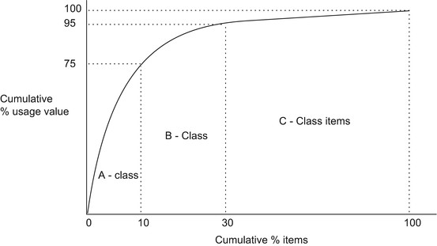

|  |  |  |
| --- | --- | --- |
| Class | Rupee value of items | No.of items |
| A | 70% | 10% of total  items |
| B | 20% | 20% of total  items |
| C | 10% | 70% of total  items |

### Advantages of ABC Analysis

* It ensures a closer and a more strict control over such items, which arc having a sizable investment in there.
* It releases working capital, which would otherwise have been locked up for a more profitable channel of investment.
* It reduces inventory-carrying cost.
* It enables the relaxation of control for the 'C' items and thus makes it possible for a sufficient buffer stock to be created.
* It enables the maintenance of high inventory turn over rate.

### Disadvantages of ABC Analysis

* It is a complex system which consists of various cost pools and cost driver rates
* It is difficult to attribute cost to single activities, some cost support several activities.
* ABC requires total commitment and support from top level management.
* Implementation of ABC requires bulk amount of time and money.
* ABC requires positive attitudes and employees support for successful implementation.

### Procedure for ABC analysis

1. Make the list of all items of inventory and the annual volume of usage.
2. Determine the annual usage for all the items by multiplying each item's annual volume by its rupee value.
3. Determine the ranks by annual usage for all the items
4. Rearrange the items by ranking
5. compute the cumulative annual usage value
6. Determine of annual usage % for all the items
7. Group the items into A, B and C by deviding the items into 70%, 20% and 10% of annual usage %

### Control policies for A, B and C class items A Items:

* + Tight controls
  + Rigid estimates of requirements
  + Strict and close watch
  + Safety stocks should be low
  + Management of items should be done at top management level.

### B- Items:

* + Moderate control
  + Purchase based on rigid requirements
  + Reasonably strict watch and control
  + Safety stocks moderate
  + Management be done at middle level

### C- Items:

* + Ordinary control measure
  + Purchase based on usage estimates
  + Controls exercises by store keeper.
  + Safety stocks high
  + Management be done at lower levels..

### Characteristics of ABC analysis method

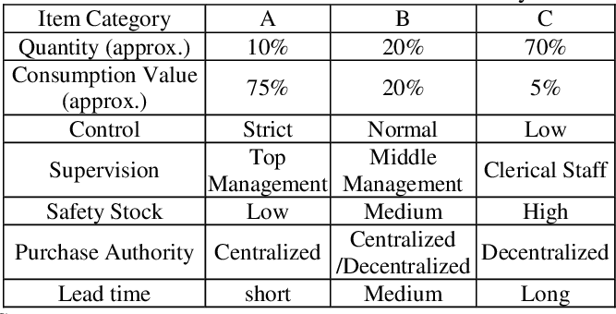

**VED Analysis:**

The items in an inventory are categorized according to their importance of production as **Vital, Essential** and **Desirable** items

**Vital** (Highly important):

* "Vital" category includes inventory, which is necessary for production or any other process in an organization.
* If any such inventory is unavailable, entire production may stop.
* Therefore, order for such inventory should be before-hand.

**Essential** (Moderately important):

* The essential category includes inventory, which is next to being vital.
* Loss due to their unavailability may be temporary, or it might be possible to repair the stock item or part.
* Ensure optimum availability and maintenance.

**Desirable** (Less important):

* The desirable category of inventory is the least important among the three.
* Unavailability may result in minor stoppages in production.
* Moreover, the easy replenishment of such shortages is possible in a short duration of time.

### Advantages of VED analysis

* + It can be used for monitoring and control of stores and spares inventory by classifying them into three categories.
  + Possible to determine the criticality of an item and its effect on production and other services.
  + It can be used for controlling and maintain the stock of items of their important in production

### Comparison of ABC and VED Analysis systems

|  |  |
| --- | --- |
| ABC analysis | VED analysis |
| 1. Items are classified according to their value | 1. Items are classified according to the  importance in Production. |
| 2. The items are classified into A(high valued), B (medium valued ) and c  (Low valued items | 2. The items are classified into V (vital), E (Essential), D (Desirable items |
| 3. Close control is provided on A class | 3. Close contool is provided on v' class |

|  |  |
| --- | --- |
| items | items |
| 4. Small quantity of A class items are maintained | 4. Large quantity of V class items are  maintained |
| 5. C class items are maintained in large quantities | 5. D class items are maintained in small  quantities |
| 6. Inventory maintenance cost for A class items is less | 6. Inventory maintanance cost for V class  items is large. |
| 7. Service level for A class items is low | 7. Service level for C class items is high |
| 8. Service level of inventory increases from A to C | 8. Service level of inventory increases from D to V. |
| 9. The cost of inventory increases due to their presence | 9. The cost of production increases due to their absence |

**Combination of ABC & VED analysis:**

|  |  |  |  |
| --- | --- | --- | --- |
|  | V | E | D |
| A | AV | AE | AD |
| B | BV | BE | BD |
| C | CV | CE | CD |

Combine both and classify the materials depending on both the consumption value and the criticality, it will give a fruitful result. This can be done in nine ways

* This type of classification helps the management to decide the materials policy and what the service levels are expected to see that no difficulty is faced.
* An item belongs to both A and V class is costlier, at the same time higher criticality, the management should see that it is available at any time the need arises and the stock levels to be controlled properly to see that inventory carrying cost are kept under control.

# MATERIAL REQUIREMENT PLANNING (MRP - I)

MRP refers to the basic calculations used to determine components required from end item requirements. It also refers to a broader information system that uses the dependence relationship to plan and control manufacturing operations.

*“Materials Requirement Planning (MRP) is a technique for determining the quantity and timing for the acquisition of dependent demand items needed to satisfy master production schedule requirements.”*

**Objectives of MRP**

1. **Inventory reduction:** MRP determines how many components are required when they are required in order to meet the master schedule. It helps to procure the materials/ components as and when needed and thus avoid excessive build up of inventory.
2. **Reduction in the manufacturing and delivery lead times:** MRP identifies materials and component quantities, timings when they are needed, availabilities and procurements and actions required to meet delivery deadlines. MRP helps to avoid delays in production and priorities production activities by putting due dates on customer job order.
3. **Realistic delivery commitments:** By using MRP, production can give marketing timely information about likely delivery times to prospective customers.
4. **Increased efficiency:** MRP provides a close coordination among various work centres and hence help to achieve uninterrupted flow of materials through the production line. This increases the efficiency of production system.

**MRP SYSTEM**

The inputs to the MRP system are:

* 1. A master production schedule,
  2. An inventory status file and
  3. Bill of materials (BOM).

Using these three information sources, the MRP processing logic (computer programme) provides three kinds of information (output) for each product component: order release requirements, order rescheduling and planned orders.

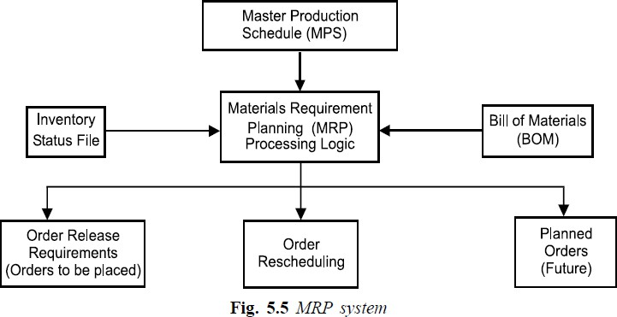

### Master Production Schedule (MPS)

MPS is a series of time phased quantities for each item that a company produces, indicating how many are to be produced and when. MPS is initially developed from firm customer orders or from forecasts of demand before MRP system begins to operate. The MRP system whatever the master schedule demands and translates MPS end items into specific component requirements. Many systems make a simulated trial run to determine whether the proposed master can be satisfied.

### Inventory Status File

Every inventory item being planned must have an inventory status file which gives complete and up to date information on the on-hand quantities, gross requirements, scheduled receipts and planned order releases for an item. It also includes planning information such as lot sizes, lead times, safety stock levels and scrap allowances.

### Bill of Materials (BOM)

BOM identifies how each end product is manufactured, specifying all subcomponents items, their sequence of build up, their quantity in each finished unit and the work centres performing the build up sequence. This information is obtained from product design documents, workflow analysis and other standard manufacturing information.

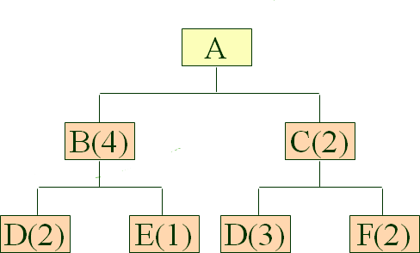

**Outputs of MRP:**

The outputs of any MRP System are:

* 1. Planned order schedule which is a plan of the quantity of each material to be ordered in each time period. The order may be purchase order on the suppliers or production orders for parts or sub-assemblies on production departments.
  2. Changes in planned orders (reschedule notices).
  3. "Recommended Purchasing Schedule". This lays out both the dates that the purchased items should be received into the facility AND the dates that the Purchase orders, or Blanket Order Release should occur to match the production schedules.

## WHERE TO USE MRP :

MRP is the most useful scheduling technique for many industries engaged in fabricating and assembling products like automobiles, tractor-trailer equipments, Rail coaches, etc., It is especially suitable for situations where one or all of the following conditions exists :

1. The final product is complex and made up of several levels of assemblies.
2. The final product is expensive.
3. The lead times for components and raw materials are relatively long.
4. The manufacturing cycle is long for the finished product.
5. Consolidation of requirements for several products is desirable so that economic lot sizes are applicable.

# Manufacturing Resource Planning (MRP II)

It should be easy to see that all the MRP schedules are driven by the Master Production Schedule (MPS). They all assume that the capacity to produce these items and meet the MPS exists. Most systems implemented today are not the simple MRP systems that we just discussed. But, they are

MRP II systems, which is defined as:

*An integrated system which utilizes a set of decision rules to determine optimal shop loading (when, how much, and priorities) to accomplish the MPS within the capacity of the facility.*

Integration means that MRP II links together all the high level planning of the company (Marketing Plan, Financial Plan, and Production Plan) with the lower level systems required to meet these plans (MRP, MPS, Shop Floor Control, Purchasing, Inventory, etc.) This assures that all system elements are working toward the same goal of meeting customer demand. The decision rules are ways in which the MRP II system trades off planned production of one item for production of other items. An example of one of these decision rules is the choice of lot sizing technique, such as: Lot-by-Lot or POQ ordering.

The MRP II system must assure that the production facility is capable of accomplishing the MPS or all these plans can result in an inability to meet promised delivery dates. This is performed in an iterative manner as depicted in Figure 5.

The company’s strategic plans for the future are translated into a MPS. MRP schedules are constructed to support this MPS. The next step is to perform Capacity Requirements Planning (CRP).

* This tells us what equipment, personnel, and materials we need to meet the MRP schedules.
* If we do not have this capacity, then the MPS and possibly the strategic plans must be revised.
* This process continues until our MRP schedules are consistent with the plant capacity.
* These schedules are then released to the departments that are responsible for performing the production and/or purchasing operations.
* These production operations continuously feed back actual accomplishment information to the MRP/MPS elements that allow the plans to be updated.
* This creates a truly closed loop manufacturing planning and execution system.

Manufacturing Resource Planning (MRP II) Capacity Requirements Planning (CRP).

Master Production Schedule (MPS)

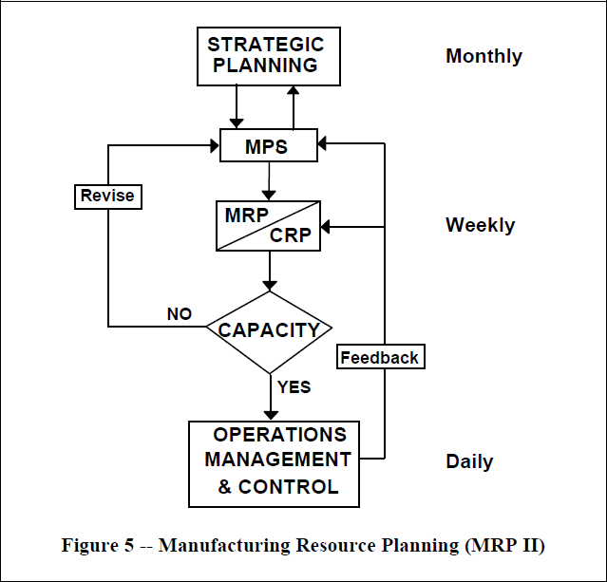

MRP II will:

* Identify WIP cost drivers,
* Insure proper Kanban size,
* Insure incoming materials availability,
* Prevent stockouts,
* Accommodate capacity constraints, and
* Track customer orders.

**Enterprise resource planning** (**ERP**) is the integrated management of main business processes, often in real time and mediated by software and technology. ERP is usually referred to as a category of [business management software](https://en.wikipedia.org/wiki/Business_management_tools)—typically a suite of integrated [applications](https://en.wikipedia.org/wiki/Application_software)—that an organization can use to collect, store, manage, and interpret data from many [business](https://en.wikipedia.org/wiki/Business_sector) activities.

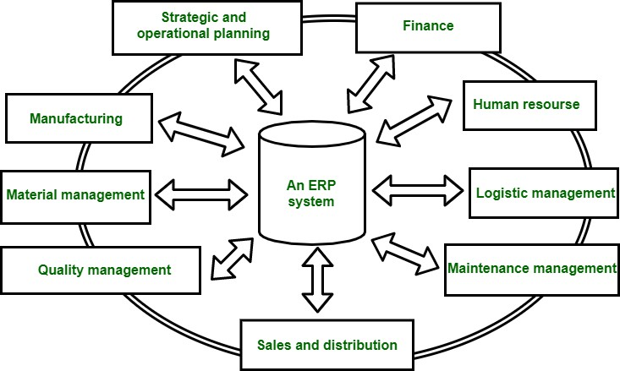

Before an ERP system, there are different databases of different departments which they managed by their own. The employees of one department does not know about anything about other department.

After ERP system, databases of different departments are managed by one system called ERP system. It keep tracks of all the database within system. In this scenario, employee of one department have information regarding the other departments.

**Benefits of ERP :**

* This system helps in improving integration.
* It is the flexible system.
* There are fewer errors in this system.
* This system improved speed and efficiency.
* There is a complete access to information.
* Lower total costs in complete supply chain.
* This system helps in Shortening the throughput times.
* There is sustained involvement and commitment of the top management.

**Line of Balance (LOB)**

Line of balance is a technique which is used to find out the state of completion of various process stage of a product which has limited production volume at a given time

## APPLICATION AREAS OF LOB

Some application areas where LOB can be applied are listed below:

* production of aircrafts
* production of missiles
* production of heavy machineries/equipments
* production of special equipments/machineries
* application software development projects which are having more or less similar modules From the above examples, one can notice a unique feature of limited production volume because of restricted demand.

## INPUT TO LOB

The list of inputs to LOB is given below:

* Product structure (Process stages with lead times)
* Monthly production volume of the product
* Time of review
* Cumulative units of production at each process stage

## STEPS OF LOB

The steps of LOB are listed below:

*Step 1.* Draw the process plan for producing one unit of the product using the pro duct structure

*Step 2.* Construct a cumulative delivery schedule and corresponding graph.

*Step 3.* Construct LOB chart (Progress chart) by the side of the cumulative delivery schedule graph for a given time period.

*Step 4.* For each process stage, find the status of completion.

# Just-In-Time (JIT)

**Introduction:**

The Just-In-Time (JIT) manufacturing system is a planning system for manufacturing processes that helps in achieving high-volume production using the minimal inventories.

The system eliminates the inventory of raw materials, work in progress, and finished goods by making them available as and when required. The items are picked up by the worker and fed directly into the production process. The finished goods are produced only at the time they are required for sale.

The implementation of the JIT System requires complete transformation of methods of designing products and services, assigning responsibilities to workers, and organizing work. In this book, we shall go through the concepts of the JIT System, its advantages,

characteristics, and its contribution toward improving the productivity and profitability of a firm.

**Objectives of JIT:**

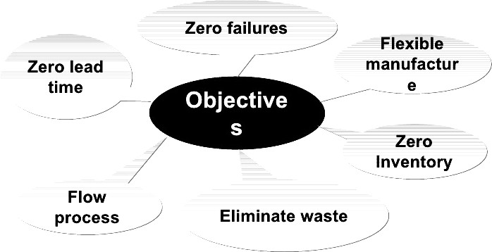

### The Concept of the JIT System:

The JIT concept states “nothing is produced until it is required.” According to the JIT system, the finished goods are assembled just before they are sold, the sub assemblies are made just before the products are assembled and the components are fabricated just before the sub- assemblies are made. Here, the work-in-progress inventory is always kept at a low level, thus reducing the production lead times. The firms should achieve and maintain high performance levels in all their operational areas to facilitate the smooth flow of materials in the JIT Systems.

The JIT System involves the active participation, involvement, and cooperation of all its employees. The JIT manufacturing system is based on the concept of continuous improvement, which includes the two mutually supporting components of people involvement and total quality control.

**People Involvement:** The Human Resources Management component plays a vital role in the implementation of the JIT manufacturing system. The successful implementation of a JIT program requires teamwork, discipline, and supplier involvement.

**Team Work:** Team Work involves activities like suggestion programs, and quality circle programs which enable employees to actively participate. Suggestion programs are conducted to encourage the employees to their ideas on how to improve a process. In quality circles, people working in similar types of operations meet at regular intervals and discuss ways to improving the quality of their processes.

**Supplier Involvement:** Firms can allow suppliers to participate in design review and to suggest new designs and methods for improving product quality or productivity. JIT firms enter into contracts with their suppliers instead of inviting competitive bids from a set of suppliers. The JIT firm can share its production plans and schedule with its suppliers so that they can plan their business and capacity requirements before hand. Linear production

schedules relate to the development of production schedules with uniform workloads. The suppliers should tailor their schedules to the JIT firm's needs as they contribute to the improvement of the firm's manufacturing operations. The maintenance of linear production schedules requires the identification and elimination of production bottlenecks, a balance in the production system, and a reduction in set-up time.

**Total Quality Control:** A firm can produce high quality products only through the combined efforts of all the departments including the purchase department, quality control department, and personnel department. The concept of 'immediate customer' helps the firms to achieve the required quality levels.

**Concept of Immediate Customer:** A JIT uses the concept of 'immediate customer' where each worker in the firm considers the next worker who continues the production process as the customer. Therefore, it is the responsibility of the worker to ensure that the product is processed to meet specifications and quality requirements before passing it on to the next worker.

Only items of acceptable quality are delivered to the immediate customer. In case a worker delivers a defective item or an improperly finished item to his/her immediate customer, the worker who identifies the defect is authorized to stop the process and take necessary actions thereafter.

### Continuous Improvement:

In a JIT System, firms adopt continuous improvement in quality and productivity by identifying areas that require improvement. Problems are detected before they occur and are solved in the minimum possible time, to ensure smooth flow of work. For manufacturing operations, the percentage of scrap can be reduced by following better work methods and training employees. A proper master production schedule and flexible workforce can be developed to eliminate the capacity imbalances.

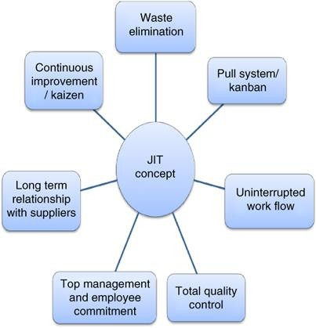

### Advantages of JIT System

The advantages of JIT System to firms are

* + Increased utilization of machinery and equipment,
  + Reduced investment in inventory,
  + Improvement in the quality of product or service,
  + Reduction in space requirements of the firm,
  + Reduction in production cycle time,
  + Zero inventory storage and maintenance costs,
  + Closer relationship with suppliers,
  + Reduction in formal paper work, and
  + Higher involvement of employees as they are responsible for producing good quality goods.

### Characteristics of JIT System:

The proper implementation of the JIT principles helps in producing products and services at the quality and price demanded by customers. The following are the characteristics of a JIT System:

### Uniform Workstation Loads:

By using JIT system, firms can maintain uniform work-loads at the workstations.

### Small Lot Sizes:

In a JIT Manufacturing system, firms maintain inventory in the smallest possible lot sizes. This is done to reduce the cycle inventory, cut lead times, and achieve a uniform work load. Smaller lots have a lower waiting time in the production process when compared to the larger lots.

### Closer Supplier Ties:

JIT firms should maintain long-term relationships with their suppliers as they are responsible for providing the timely delivery of good quality inventory.

### Maintenance of High Quality:

In the JIT system, quality control begins from the source where the workers are encouraged to maintain the quality of work. The production process is stopped immediately when a quality problem is identified and is continued only after the problem has been sorted out.

### Quick and Economic Set Ups:

Generally, firms manufacture their products in large lots leading to lower number of machine set ups. Firms using JIT system experience a larger number of set-ups as they produce in small lots. JIT firms, therefore, need quick and inexpensive set-ups in order to minimize the disadvantages of having more set ups. JIT firms engage specialists and consultants to train their workers to reduce set-up times. The following is the procedure to reduce set-up times.

### Preventive Maintenance:

In order to reduce the occurrence of defects, firms should carry out preventive maintenance. In preventive maintenance, the parts that are likely to produce defects are replaced, rather than the defects that arise during production being repaired. Workers are given the responsibility of maintaining their machinery and equipment and are also trained to solve or repair common problems.

The following are the important principles and actions that improve equipment maintenance.

* Design simple equipment and standardize replacement parts
* Collect information about the frequency and causes of failures of machines
* Replace worn out parts of equipment, after periodic checks
* Purchase all spare parts that are necessary during repair work

# Kanban System :

*Kanban, also* spelt *“*kamban*” in Japanese, translates to “Billboard” (“signboard” in Chinese) that indicates “available capacity (to work)”.*

### Types of kanban systems

1. **Production (P) Kanban:** A P-kanban, when received, authorizes the workstation to produce a fixed amount of products. The P-kanban is carried on the containers that are associated with it.
2. **Transportation (T) Kanban:** A T-kanban authorizes the transportation of the full container to the downstream workstation. The T-kanban is also carried on the containers that are associated with the transportation to move through the loop again.

### Important Rules for Kanban:

* + A kanban should always be attached to goods.
  + The number of kanban cards should be reduced for optimum efficiency.
  + Always aim at sending products that are 100% defect free. If goods with defects are sent to the next operation, it will lead to a lot of waste and reduce productivity.
  + The quantity indicated at earlier processes by the kanban card guides the later processes.
  + Items should not be transported if a kanban is not attached to them.
  + Only produce parts that are equal to the number of kanban present. Producing more goods than the number of kanban may lead to waste of inventory.

**ROUTING:**

It is a process of deciding the sequence of operations (or route) to be performed during the production process. It determines:

* What work (operations) will be done on a product.
* Where (on which machine/dept.) these operations will be performed.
* How these operations will be performed.
* In which sequence the job (from raw material stage to finished goods stage) will move in the plant.

Therefore, the main objective of routing is the selection of best and cheapest way to perform a job.

It depends upon the following factors

* Type of available machines
* Capacity of each machine
* Labor required for each machine
* Availability of tools and other resources
* Efficiency of employees
* Types and quantities of the products to be manufactured
* Department in which the production is to be carried out

# PROCEDURE OF ROUTING

Following steps are needed in routing:

1. Conduct an analysis of the product to determine the part/components/sub-assemblies, required to be produced.
2. Conduct an analysis to determine the material needed for the product.
3. Determine the required manufacturing operations and their sequence.
4. Determine the lot size (i.e., units of items to be manufactured in each lot of production or order) to be produced (or purchased).
5. Determine the scrap and rejections at each stage of production.
6. Estimate the cost of the product.
7. Prepare different forms for production control, such as: production order form, job-card, labor card, inspection card, tool tickets, route sheet, move ticket, etc.

# ROUTE SHEETS

It is a document with specific manufacturing sequence of operations. The precise route, which must be followed, is given in the route sheet. A typical route sheet contains the following information:

* 1. Number and identification of work order
  2. Symbol and/or identification of a part
  3. Estimated number of pieces to be produced
  4. Number of parts in each lot
  5. Operations needed on the given part
  6. Sequence in which these operations are performed
  7. Machines or equipments to be used for each operation, and
  8. Estimates of set-up and run time per piece of production.

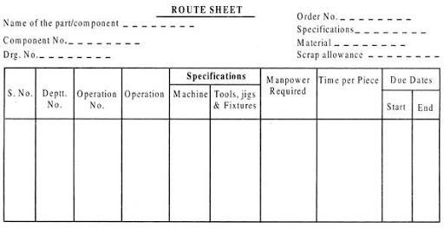Different route sheets are needed for different parts. These may be used to determine the schedule for each production order. These serve as useful guiding document in the production process, as the supervisor knows that after finishing a particular operation, the part will go to which department and at what time. In essence, routing is the planning of what works are to be performed on the job, and in what sequence these would be operational.

**Bill of materials (BOM):**

A bill of materials (BOM) serves as a complete list of all the materials and parts—virtually every item—that a manufacturer needs to create a certain product. To be effective, the BOM needs to include not only the raw materials but also any subassemblies, subcomponents, and parts—and the precise quantities of each.

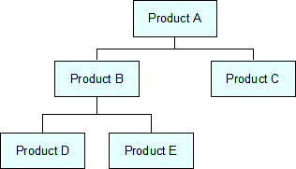 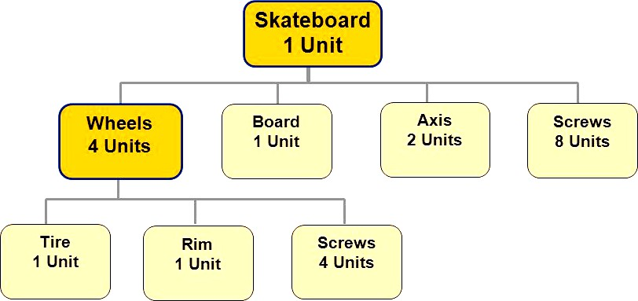

# SCHEDULING AND LOADING

**SCHEDULING** : Scheduling involves fixing the priorities for different jobs and deciding the starting and finishing time (or date) of each job. It also includes the scheduling of different materials, parts, machines, tools, equipments, inspection, etc.

Main purpose of scheduling is to prepare a time-table indicating the time and rate of the production, as indicated by starting and finishing time of each activity. The scheduling can be effective when it utilizes the informational inputs, such as: existing work-load, lead time, manufacturing time, importance of each job, due date, priority rule to handle each part when there is a queue before an operational facility.

## Objectives of Scheduling and Loading:

1. Scheduling aims to achieve the required rate of o/p with a minimum delay and disruption in processing.
2. To provide adequate quarters of goods necessary to maintain finished product at levels predetermined to meet the delivery commitment.
3. The aim of loading and scheduling is to have maximum utilization of men, machines and materials by maintaining a free flow of materials along the production line.
4. To prevent unbalanced allocation of time among production departments.
5. To keep the production cost minimum.

## Factors Affecting Scheduling

* 1. **External Factors**

1. Customers demand
2. Customers delivery dates
3. Stock of goods already lying with the dealers & retailers.

## Internal Factors

1. Stock of finished good with firm
2. Time interval to manufacture each component, subassembly and then assembly.
3. Availability of equipments & machinery their capacity & specification.
4. Availability of materials
5. Availability of manpower

## Types of Scheduling

* 1. Forward Scheduling
  2. Backward Scheduling

## Forward Scheduling

* Assigning customer orders or jobs to various works centres based on `as early as possible'. A job is scheduled at a work centre as soon as it is free to process job.
* The job is then finished as soon as possible. This approach is based on the assumption that a customer is ready to receive the goods as soon as these are produced.
* Forward scheduling may result in jobs being completed earlier then the requested due date because forward scheduling schedules the tasks as early as possible.
* Forward scheduling tells when a job could be completed

## Backward Scheduling

* Another way of scheduling is backward scheduling. 'as last as possible' that jobs are finished by their due dates for delivery to the customer. The planning process starts with assigning the job to the last work centre in the processing sequence.
* According to the processing time of the job at the various work centres, the schedule is worked out towards the beginning of the processing sequence. This approach results on a significant reduction of work in progress / inventory
* Backwards scheduling requires a delivery date from the customer because the system schedules backwards from the delivery date to arrive at a start date.

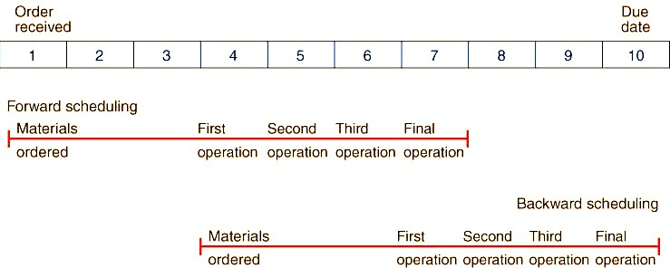

For example, some urgent works, which are called as rush orders, may have to be given priority preference over already existing repeat orders. Scheduling must be in tune with the availability of machines and facilities, material, labour, part drawing, process-sheet (or route sheet), etc. Scheduling is one of the most important activities of the PPC as it determines the real activities on the shop-floor.

Scheduling activity involves the following charts :

1. Master Production Schedule (MPS)
2. Machine Load Chart
3. Gantt Chart

## Master Production Schedule (MPS)

A **master production schedule** (**MPS**) is a [plan](https://en.wikipedia.org/wiki/Production_planning) for individual commodities to be produced in each time period such as production, staffing, inventory, etc. It is usually linked to manufacturing where the plan indicates when and how much of each product will be demanded. This plan quantifies significant processes, parts, and other resources in order to optimize production, to identify bottlenecks, and to anticipate needs and completed goods. Since a MPS drives much factory activity, its accuracy and viability dramatically affect profitability.

## Machine Load Chart

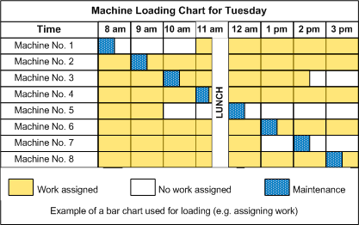

1. **Gantt chart**:

A **Gantt chart** is a type of [bar chart](https://en.wikipedia.org/wiki/Bar_chart) that illustrates a [project schedule](https://en.wikipedia.org/wiki/Schedule_(project_management)). This chart lists the tasks to be performed on the vertical axis, and time intervals on the horizontal axis. The width of the horizontal bars in the graph shows the duration of each activity. Gantt charts illustrate the start and finish dates of the terminal elements and summary

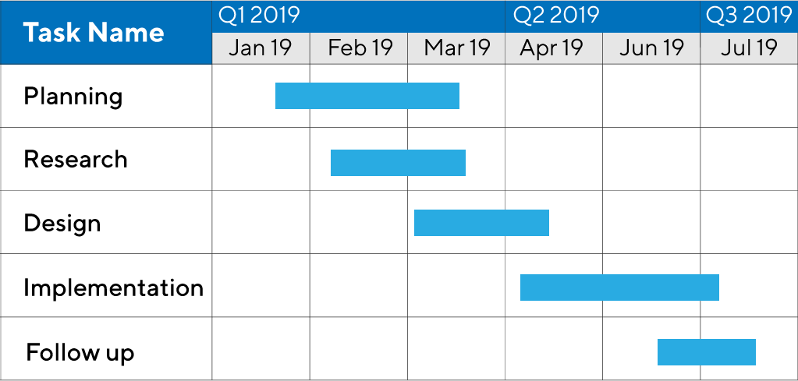elements of

a [project.](https://en.wikipedia.org/wiki/Project)

# LOADING:

The next step is the execution of the schedule plan as per the route chalked out it includes the assignment of the work to the operators at their machines or work places.

Loading is defined as the relationship between load and capacity, so as to assign the work for the production.

**Capacity:** the time available for work at work centres expressed in machine hours or in man hours.

**Load:** to assign work to the capacity available at particular work centres. It includes the assignment of the work to the operators at their machines or work places.

## Types of Loading

* 1. Finite loading
  2. Infinite loading

## Finite loading

* + Allows only as much work to be assigned as can be done with available capacity - but doesn't ' prepare for inevitable slippage
  + Finite loading considers the capacity of exact work center and compares the processing time so that process time does not exceed capacity.
  + With finite loading the scheduler loads the job that has the highest priority on all work centers it will require.
  + Then the job with the next highest priority is loaded on all required work centers, and so on.
  + This process is referred to as horizontal loading

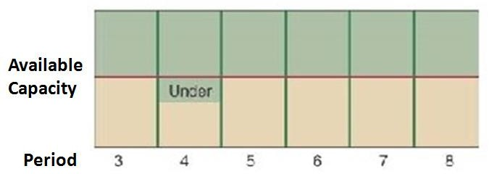

## Infinite loading

* + Ignores capacity constraints, but helps identify bottlenecks in a proposed schedule to enable proactive management
  + With infinite loading jobs are assigned to work centers without regard for capacity of the work center.
  + Jobs are loaded at work centers according to the chosen priority rule.
  + Priority rules are appropriate for use under the infinite loading approach.
  + This is known as vertical loading.

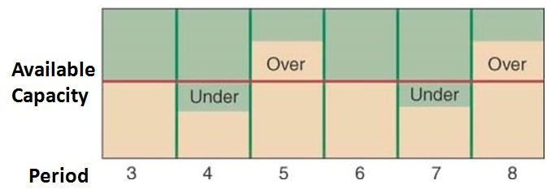

## Difference with loading:

**Routing**: Routing prescribes the sequence of operations required to transform inputs into desired output

**Scheduling:** Scheduling when and where each operation of the production process is to be performed.

**Loading:** Loading Studies relationship between load and capacity of work centres in the system.